Shrinkage correlation: AUDUSD and EURGBP
Method 08 / eight-major panel / delta = 0.2 and Ledoit-Wolf / Alpari D1 full available history

Study setup
Logical pair: AUDUSD , EURGBP
Broker symbols: AUDUSD_i , EURGBP_i
Snapshot: 2026-11-03_majors_alpari_D1
Timeframe: D1
Common eight-major panel window: 1999-01-06 to 2026-11-02 (UTC bar dates)
Panel matched return count n: 7127
Dropped unfinished last bar dated 2026-11-03 UTC after a tick-volume check against the prior complete day.
Fixed shrinkage: delta=0.2, mu=3.9170889e-05 (mean of diag(S))
Ledoit-Wolf estimated delta: 0.0042157642
Panel symbols: EURUSD, GBPUSD, AUDUSD, NZDUSD, USDJPY, USDCHF, USDCAD, EURGBP
Complete matched rows (Excel): AUDUSD-EURGBP_Shrinkage_D1.xlsx
Complete matched rows (HTML table): AUDUSD-EURGBP_Shrinkage_D1_data.html

Method carried forward
Shrinkage blends the sample covariance matrix S of matched daily log returns of close, ln(close_t / close_t-1), toward a simple target, then converts the shrunk covariance into correlations. Quotes are not inverted. This experiment builds one common calendar across all eight majors, forms S with the unbiased n-1 divisor, then reports two shrinkage specs: fixed delta = 0.2 with mu equal to the average sample variance (mu * I target), and sklearn Ledoit-Wolf with its estimated delta. Pair reports pull rho_ij from those panel matrices. Same-panel Pearson r is a side check only. Shrinkage improves conditioning; it is not a cause, not a lead, and not a trading signal.

Results
pearson_r | rho_02 | rho_LW | rho_02_minus_r | rho_LW_minus_r | delta_LW
0.036369 | 0.028273 | 0.03619 | -0.008096 | -0.000179 | 0.00421576

Conclusion
Over the common 7127-day eight-major panel for AUDUSD and EURGBP (broker quote directions unchanged), fixed-delta shrinkage correlation at delta=0.2 is 0.0283 (positive, weak linear link in this sample). Ledoit-Wolf rho is 0.0362 with estimated delta=0.004216. Same-panel Pearson r is 0.0364 (rho_02 minus r = -0.0081; rho_LW minus r = -0.0002). This does not establish cause, lead-lag, or a lasting trading rule.

Charts
Daily closes
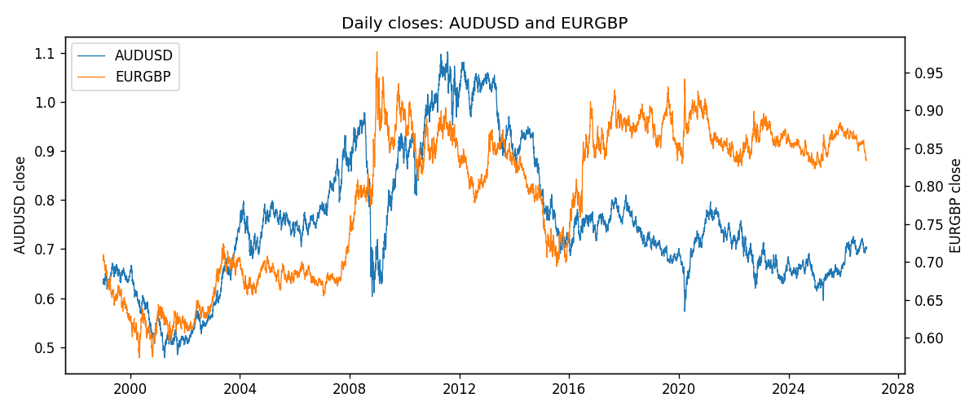
Daily log returns
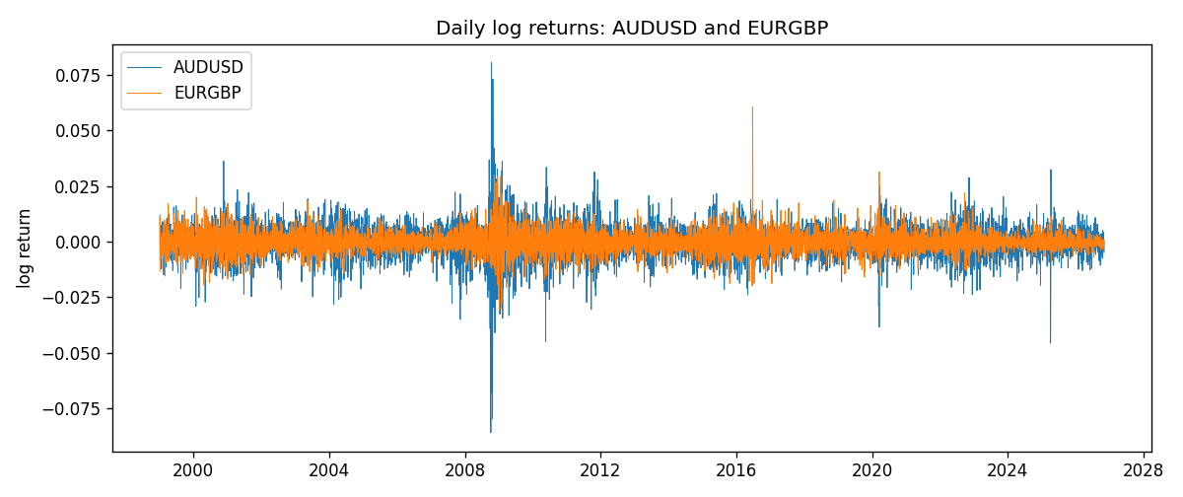
Log-return scatter
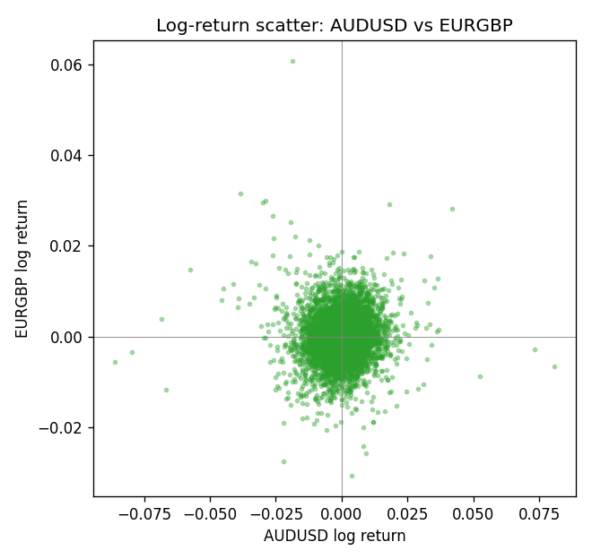

Data report
Every panel row for this pair slice is stored in the sibling Excel workbook named AUDUSD-EURGBP_Shrinkage_D1.xlsx. Full-panel covariance and correlation matrices are saved once under outputs/ as CSV files. Embedding all rows as a Word table is impractical at this length; the Word file holds the column list, column summaries, and the first and last 15 matched rows.
Columns: time, AUDUSD_open, AUDUSD_high, AUDUSD_low, AUDUSD_close, AUDUSD_tick_volume, AUDUSD_spread, AUDUSD_real_volume, AUDUSD_log_return, EURGBP_open, EURGBP_high, EURGBP_low, EURGBP_close, EURGBP_tick_volume, EURGBP_spread, EURGBP_real_volume, EURGBP_log_return
Column summaries (panel rows)
column | count | mean | std | min | 25% | 50% | 75% | max
AUDUSD_open | 7127 | 0.75283275 | 0.13531386 | 0.4785 | 0.66158 | 0.7319 | 0.812805 | 1.10284
AUDUSD_high | 7127 | 0.75689359 | 0.13587198 | 0.4878 | 0.66567 | 0.73555 | 0.8193 | 1.10795
AUDUSD_low | 7127 | 0.74877471 | 0.1346251 | 0.4775 | 0.65837 | 0.72811 | 0.80713 | 1.0975
AUDUSD_close | 7127 | 0.75288849 | 0.13529323 | 0.4786 | 0.661725 | 0.7321 | 0.812865 | 1.10169
AUDUSD_tick_volume | 7127 | 78106.737 | 138648.75 | 109 | 5647 | 44017 | 71744.5 | 1234623
AUDUSD_spread | 7127 | 30.658622 | 16.888951 | 0 | 13 | 30 | 50 | 50
AUDUSD_real_volume | 7127 | 5.2965195e+09 | 1.2602867e+11 | 0 | 0 | 0 | 0 | 3.811512e+12
AUDUSD_log_return | 7127 | 3.23e-05 | 0.0075548 | -0.08602525 | -0.00385041 | 0.00029027 | 0.00415332 | 0.0806166
EURGBP_open | 7127 | 0.78791082 | 0.09637243 | 0.5734 | 0.6884 | 0.83449 | 0.8655 | 0.9769
EURGBP_high | 7127 | 0.79099288 | 0.09674788 | 0.5789 | 0.6906 | 0.83742 | 0.868415 | 0.9799
EURGBP_low | 7127 | 0.78520819 | 0.09619038 | 0.5682 | 0.6864 | 0.83222 | 0.86303 | 0.9661
EURGBP_close | 7127 | 0.7879552 | 0.09637142 | 0.5735 | 0.6884 | 0.83458 | 0.86556 | 0.977
EURGBP_tick_volume | 7127 | 87771.585 | 145890.89 | 332 | 6734 | 44866 | 82002 | 1424684
EURGBP_spread | 7127 | 21.129928 | 19.050945 | 0 | 4 | 13 | 40 | 50
EURGBP_real_volume | 7127 | 2.8086114e+10 | 1.3572254e+11 | 0 | 0 | 0 | 0 | 3.5726265e+12
EURGBP_log_return | 7127 | 2.379e-05 | 0.00487339 | -0.03067367 | -0.00262314 | -9.978e-05 | 0.00256668 | 0.06075387
First 15 panel rows (selected columns)
time | AUDUSD_close | EURGBP_close | AUDUSD_log_return | EURGBP_log_return
1999-01-06 | 0.6289 | 0.7019 | 0.011836351 | -0.013303338
1999-01-07 | 0.6345 | 0.7097 | 0.0088650256 | 0.011051402
1999-01-08 | 0.6347 | 0.7062 | 0.00031515916 | -0.004943862
1999-01-11 | 0.6393 | 0.7053 | 0.0072213815 | -0.0012752393
1999-01-12 | 0.6362 | 0.7077 | -0.0048608485 | 0.0033970309
1999-01-13 | 0.6312 | 0.708 | -0.0078902098 | 0.00042381861
1999-01-14 | 0.6295 | 0.7066 | -0.002696916 | -0.0019793588
1999-01-15 | 0.634 | 0.7012 | 0.007123101 | -0.0076715819
1999-01-18 | 0.6346 | 0.7017 | 0.00094592471 | 0.00071280921
1999-01-19 | 0.6392 | 0.7007 | 0.0072225153 | -0.0014261269
1999-01-20 | 0.64 | 0.7021 | 0.0012507819 | 0.0019960086
1999-01-21 | 0.6405 | 0.7016 | 0.00078094498 | -0.00071240297
1999-01-22 | 0.6327 | 0.7004 | -0.012252745 | -0.0017118406
1999-01-25 | 0.6302 | 0.6966 | -0.0039591468 | -0.0054402425
1999-01-26 | 0.6305 | 0.6962 | 0.00047592608 | -0.00057438255
Last 15 panel rows (selected columns)
time | AUDUSD_close | EURGBP_close | AUDUSD_log_return | EURGBP_log_return
2026-10-13 | 0.69821 | 0.84458 | 0.0035007712 | 0.00020130374
2026-10-14 | 0.69715 | 0.84553 | -0.0015193215 | 0.0011241873
2026-10-15 | 0.69191 | 0.84479 | -0.0075447063 | -0.00087557391
2026-10-16 | 0.69426 | 0.84307 | 0.0033906408 | -0.0020380844
2026-10-19 | 0.6978 | 0.84259 | 0.0050859986 | -0.00056950988
2026-10-20 | 0.70022 | 0.83957 | 0.0034620426 | -0.0035906254
2026-10-21 | 0.70275 | 0.83839 | 0.0036066384 | -0.00140647
2026-10-22 | 0.70186 | 0.83682 | -0.0012672558 | -0.0018743924
2026-10-23 | 0.70353 | 0.83751 | 0.0023765656 | 0.00082421033
2026-10-26 | 0.70128 | 0.83762 | -0.0032032829 | 0.00013133309
2026-10-27 | 0.70245 | 0.83595 | 0.0016669876 | -0.0019957343
2026-10-28 | 0.70533 | 0.83651 | 0.0040915541 | 0.00066967224
2026-10-29 | 0.70245 | 0.83553 | -0.0040915541 | -0.0011722209
2026-10-30 | 0.70316 | 0.83351 | 0.0010102376 | -0.0024205543
2026-11-02 | 0.69971 | 0.83426 | -0.0049184984 | 0.00089940465

